**GIT: A free open source distributed version control system**

**WE can distribute the code between peers. If anyone does any change others will be notified. SVN is same as well.**

**It is a common repository.**

**Download the GIT Setup**

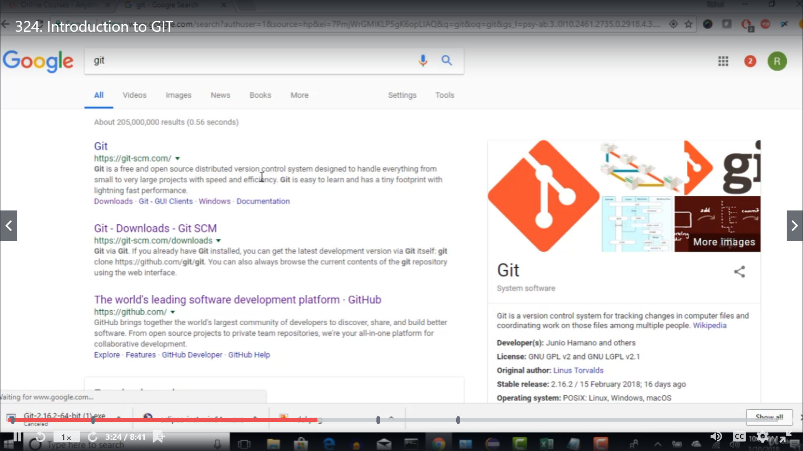

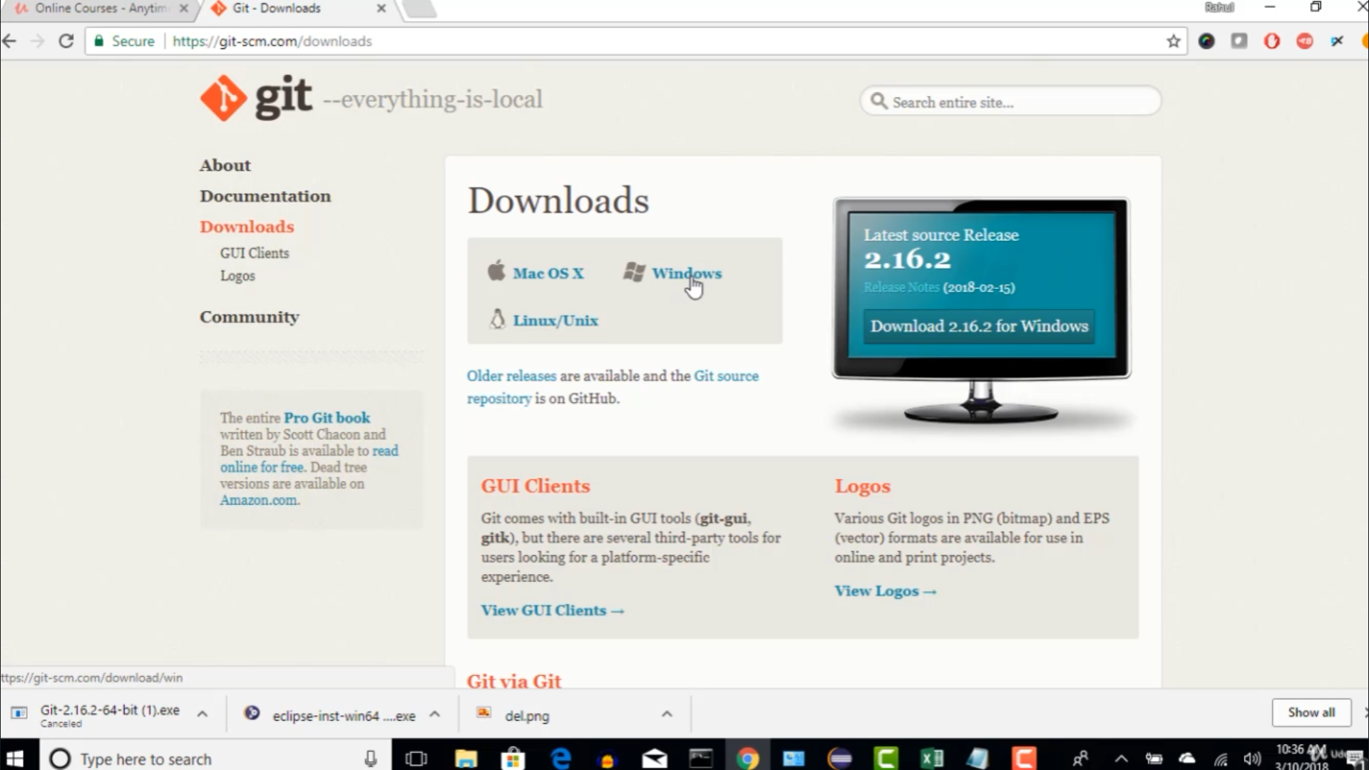

**Run the file**

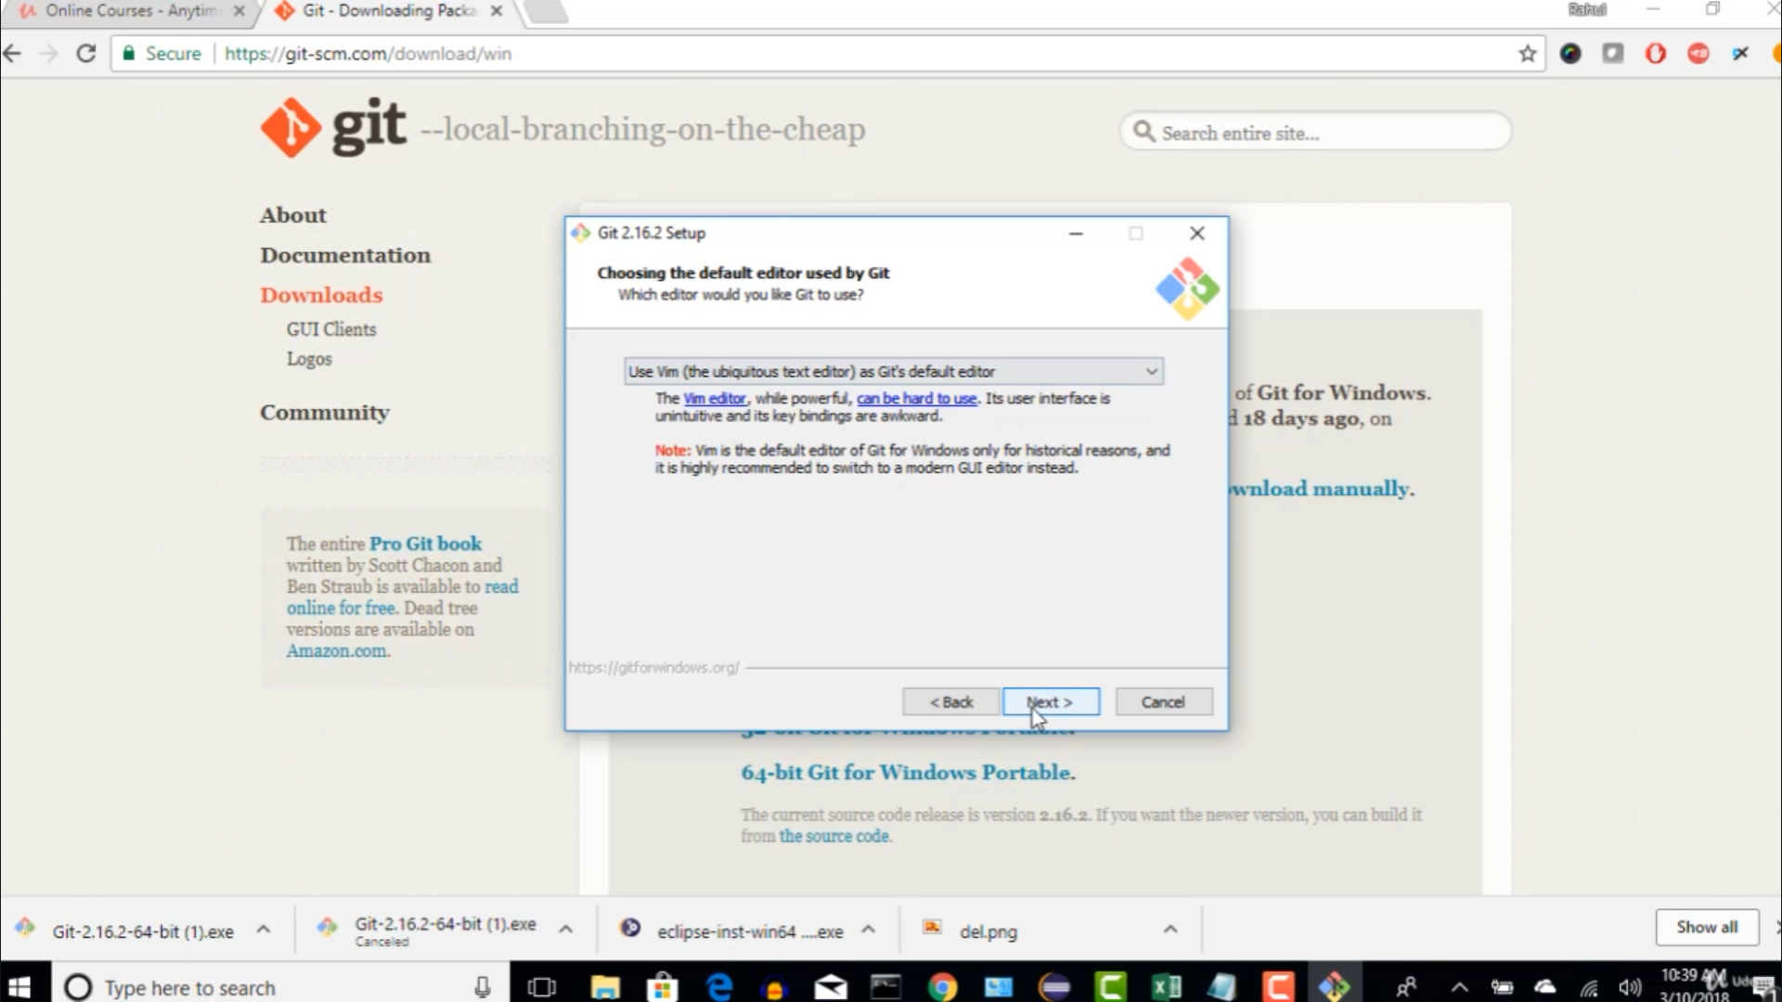

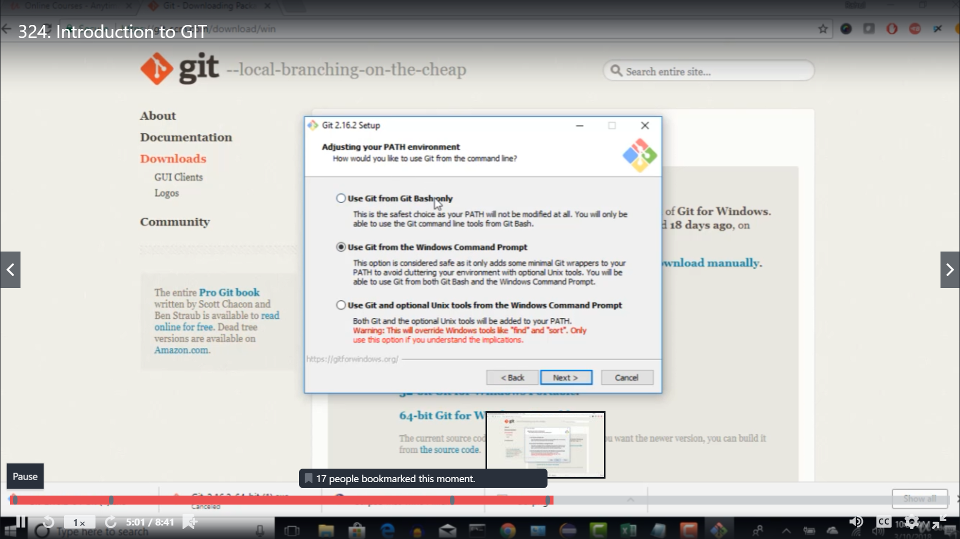

**What is GitHub**

**It is a central repository where you can push your code from local repository.**

**To talk to GITHUB we need local commands and that’s why we installed GIT file. Using that file we can talk to GIT HUB.**

**Tutorial 2: Creating an account in GitHub**



**If we use normal repository instead of GIT, if A does any change and the next day B came , he will see only the change code. His code on previous day has lost. GitHub overcomes this issue**

**Point to be remembered: If A dos any change on line 1- 5 and someone A1 came and does some minor changes on the same line 1 – 5 and then finally trying to push the code in Github, GIT became confused and says there is a conflict. Please change accordingly.**

**Tutorial3: Creating Git config and properties**

1. **Add a new repository**

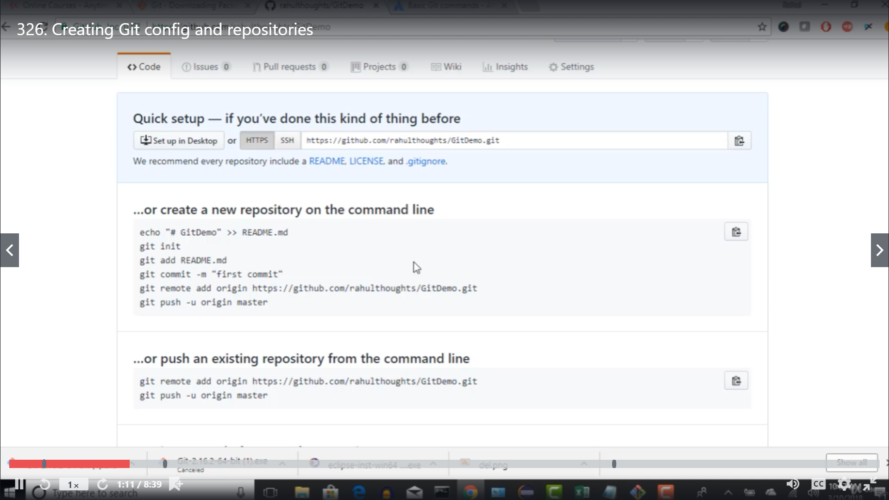

1. **Push your code from local machine to central (GitHub) or you can pull the code from GiHub to local**

**Pre-Requisite: Back end action**

**Before doing anything Git has to know the exact user for whom he will communicate to GitHub**

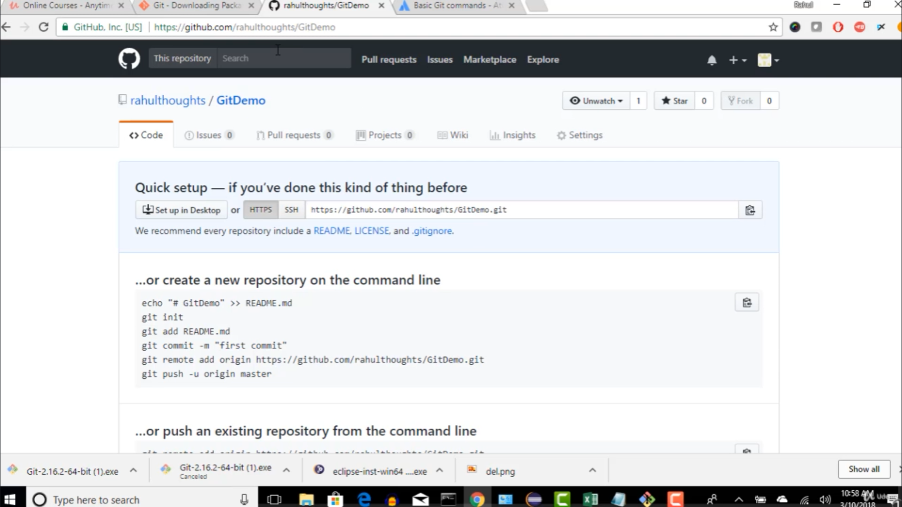

**Set up done**

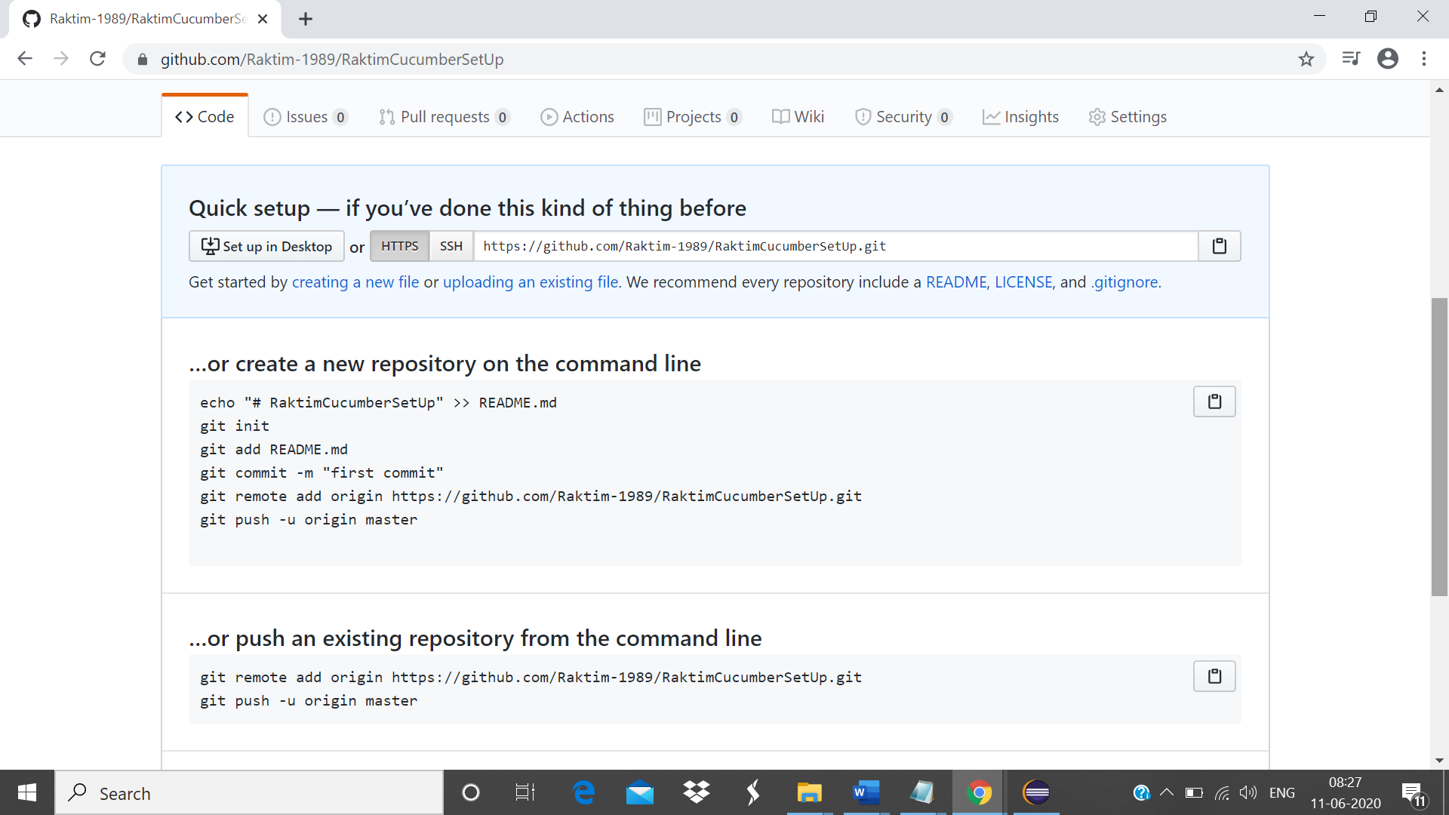

**For that reason, we will pass some commands via Git To GitHub**

1. **There are some plugins available of some tools like eclipse, intellij and all and we can easily clicks the push/pull button to push code from local or pull it into local. But we need to know how it is performing in the back end. With Git Command.**

**Totorial3: Basic Git commands**

**Tutorial:** <https://confluence.atlassian.com/bitbucketserver/basic-git-commands-776639767.html>

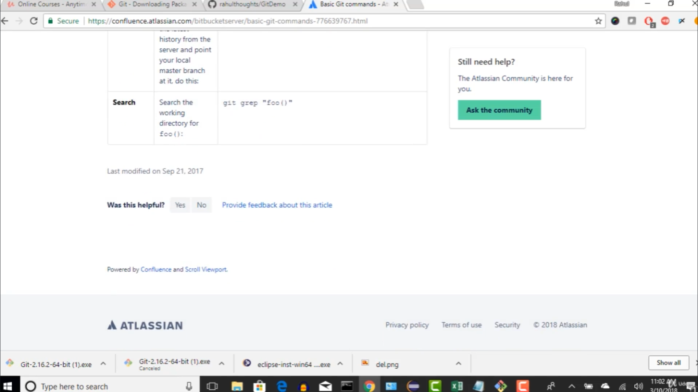

1. **Tell Git who you are. write the command in cmd prompt**

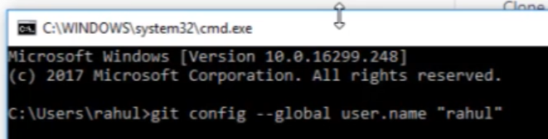



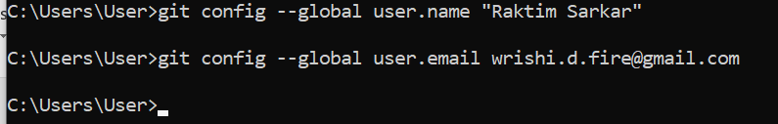

1. **Create a local repository and place your project inside it.**

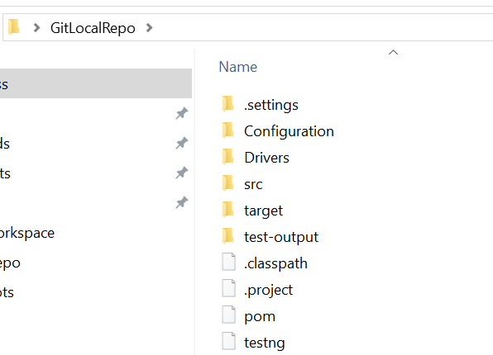

1. **Move to cmd prompt, and navigate to the folder (GitLocalRepo)**

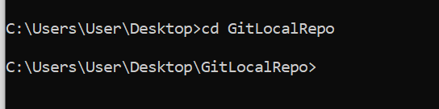

1. **Initialize this folder by the following. The importance of init command is GitHub will understand this folder when user is initializing the git file into this local folder directory. After doing the initialization of this git file into local repo GitHub will understand this local folder.**

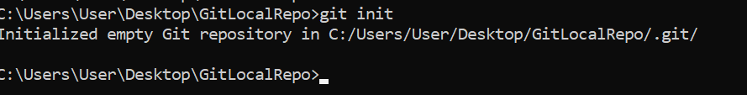

1. **Commit the code. Below is the logic behind it-**

**GitHub will only accept the code that are committed to push i.e. ‘Commit’. For commits, commits will check the codes that are from ‘Stash’.**

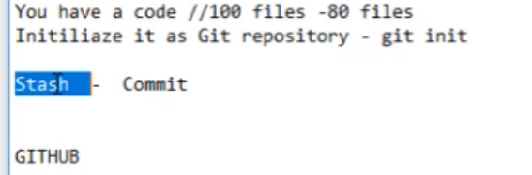

**Steps: Before pushing any code to GitHub**

**(i). Initializing the git file into local repo**

**(ii). Stash the code (add file to staging phase) and then commit it**

**(iii). Push it to GitHub finally**

1. **Since init command is done, we are going to add the code into ‘staging as following**

**Add* means add all the codes from that local repo to ‘staging’**



**Enter**

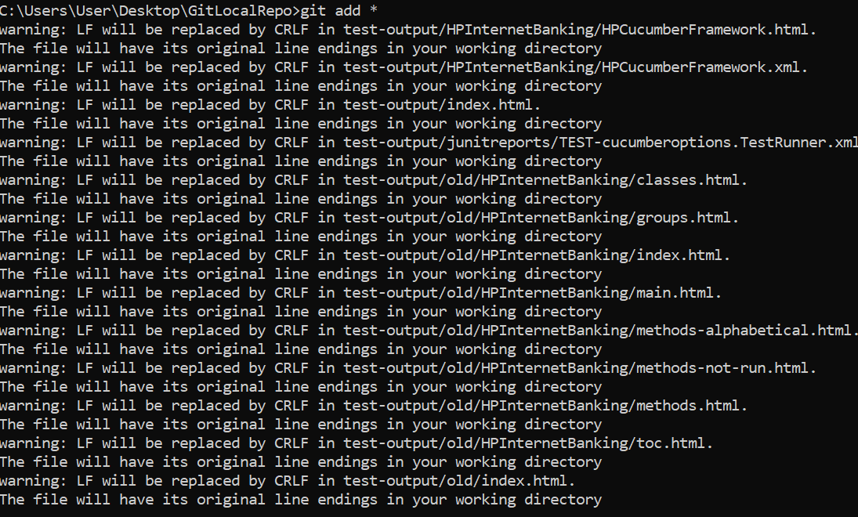

1. **Now we can check the status of what the files are added to stack by the ‘git status’**

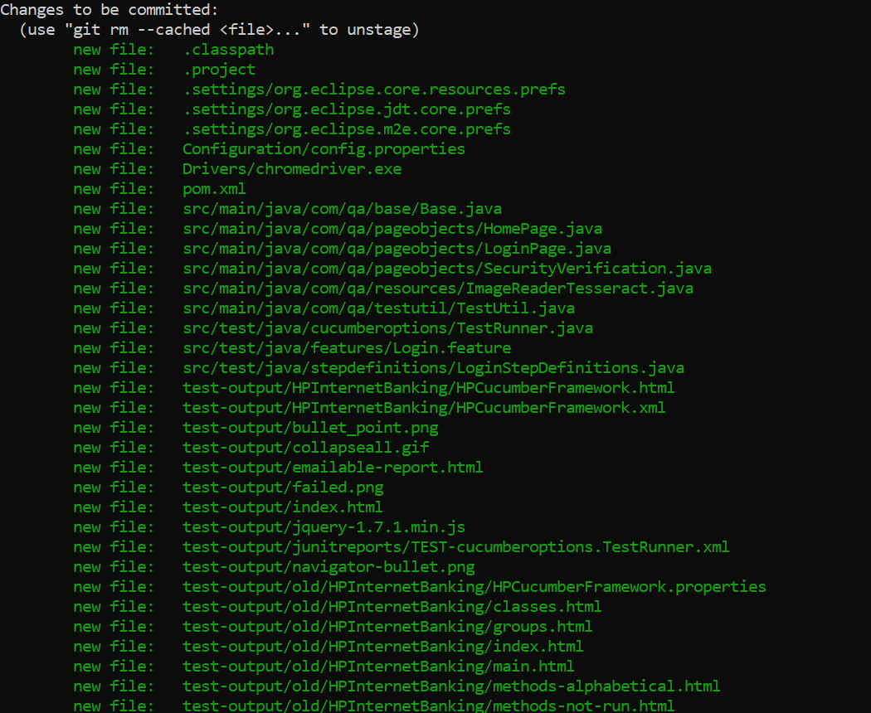

1. **Commit the code after staging git commit -m “message”**

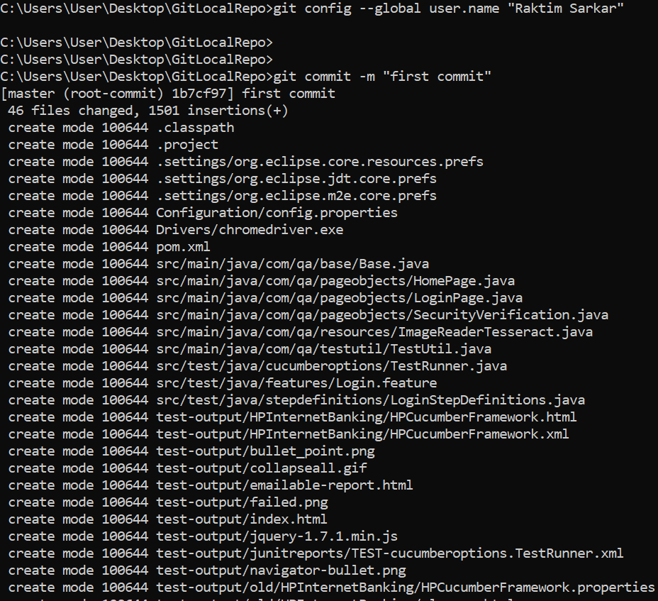

1. **The next step is to connect the remote repository with your local for pushing your artifacts.**

**Git remote add origin ‘server location of remote repo’**



1. **This step is to push your code into remote repository. The default node is ‘master’ which means when you create any new repository in GitHub the default branch is master.**

**Once you hit ENTER it will ask for credentials**

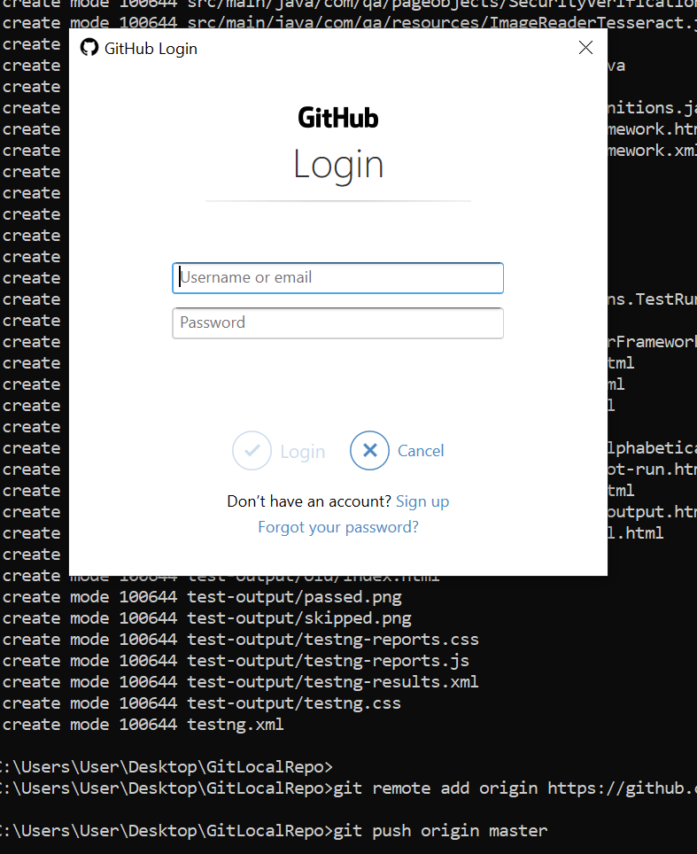

**You will see the success message –**

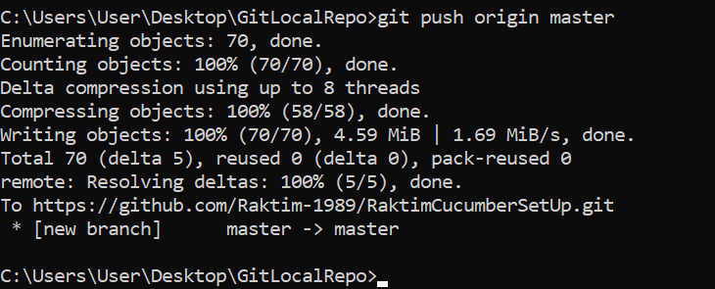

1. **Now check your remote repo in GitHub and verify the local repo is pushed into remote repo**

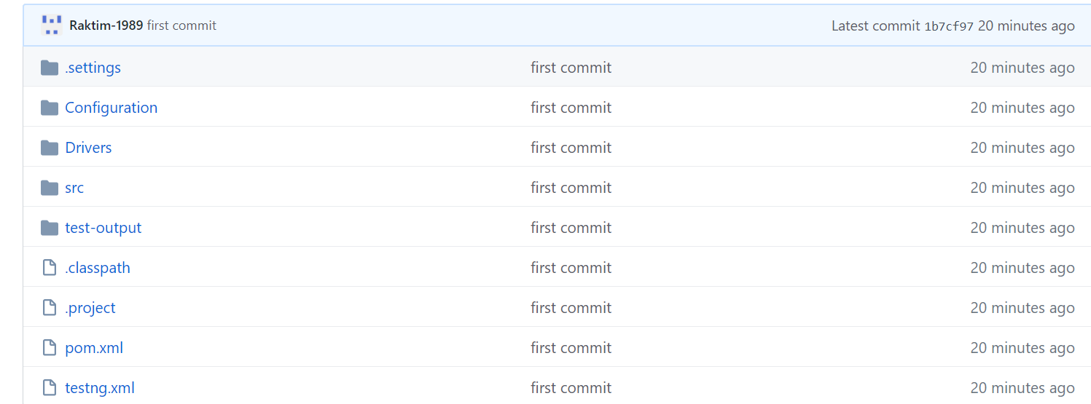

**Note the following when you will be working for your company –**

1. **In your company they will buy a domain (AD-ENT for Wells) for their remote Git repository and ask your company to send you that remote repository origin(URL). You won’t be allowed to create an account in GitHub by your own.**
2. **Also, you won’t be allowed to create a new remote repo in that remote GitHub origin. You will be always having an existing repo as the following and we have to clone into our machine**

**Ask your company to create a new repo for you and then push the committed codes into it**

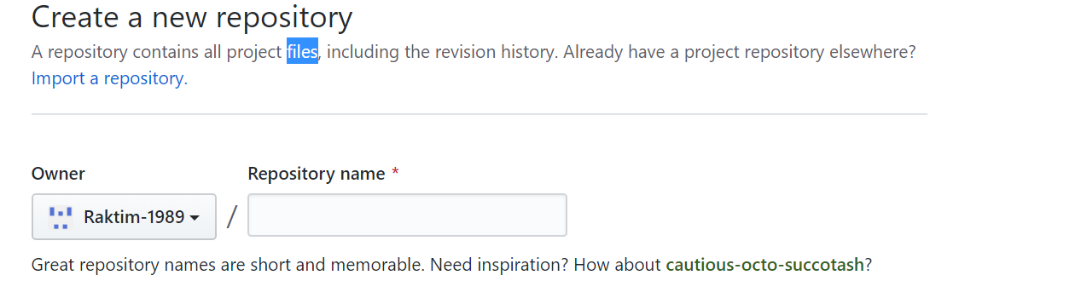

**Tutorial4: How to clone a project to your fresh repo(local repo)**

**Points to be remembered:**

1. **If we use ‘clone’ command it will copy the entire project(so it applies only for the first time when we are trying to clone any project into local).**
2. **Note: Take that from your desktop**

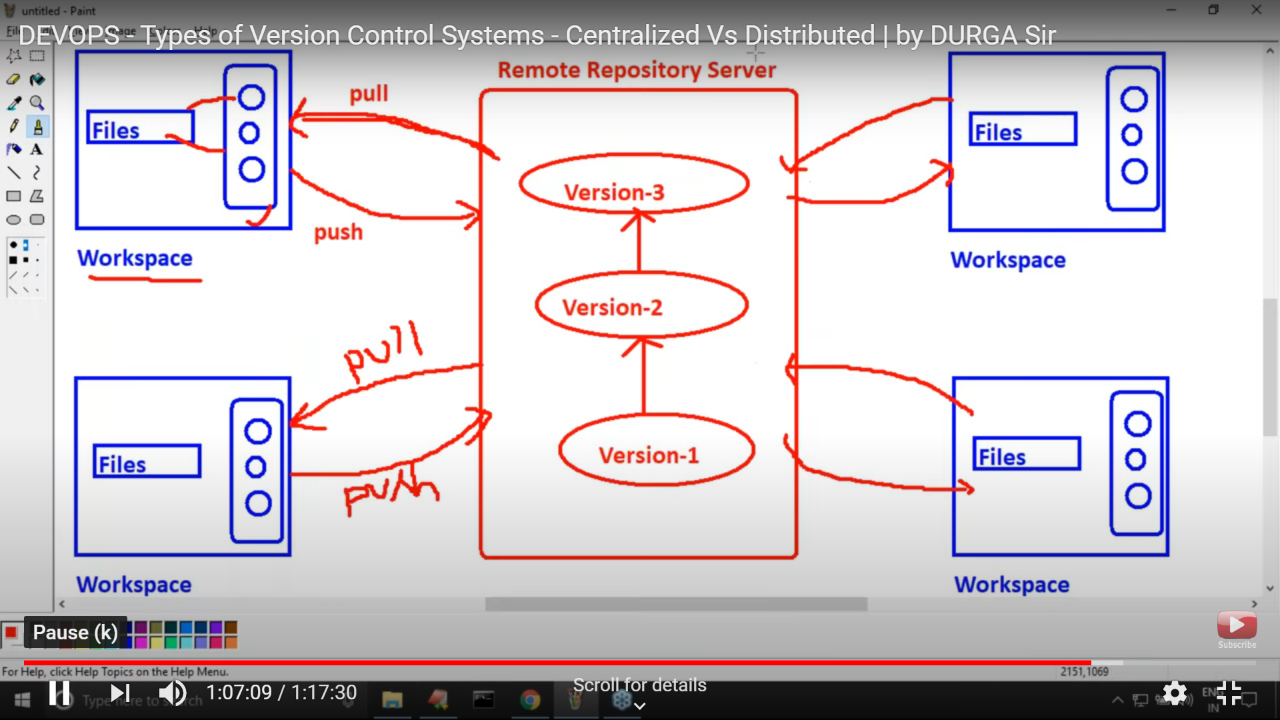

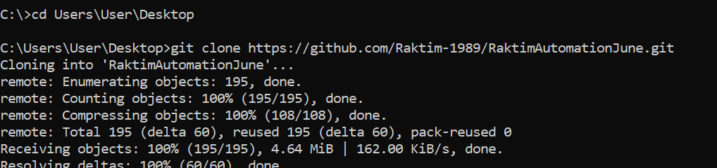

1. **If we use ‘pull’ command it only applies for any change in the existing project. After cloning, if any changes done on the code, we will use ‘pull’ command to only copy the changes.**

**Note: Take that from local repo**

**How to change any code and use of ‘pull’ command**

1. **Import your existing project into eclipse editor**

**Click import<< General**

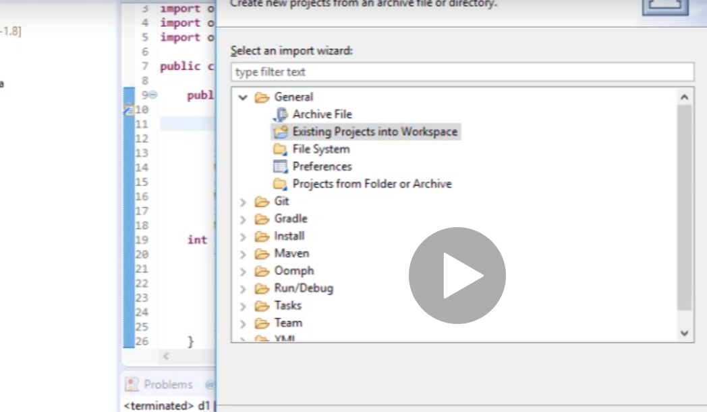

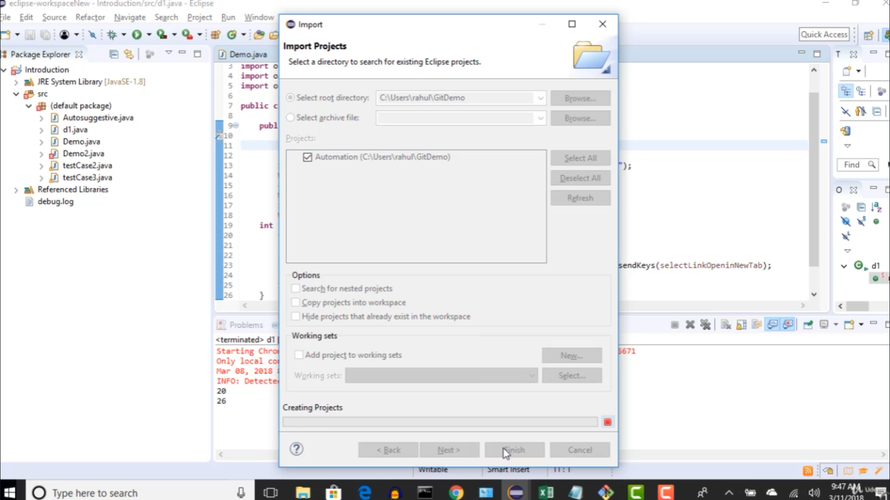

**Practical Example:**

1. **X (working on India time zone) uploads a project (GitX in remote origin) by the following**

**git init << git add* << git commit -m “first commit” <<git remote add origin “remote server location” and then he left office**

1. **Y (working on US timezone) downloads/clone the project from the central repo as following**

**git clone “remote location server” and grabs the project into his local for changes**



**Note: When he did clone he internally performed git init as well to initialize his local repo with git file.**

**Now he import the project into eclipse (first renaming the <name> in .project file) made some changes in any of the files into his local repo and push the code into remote Git repo again.**

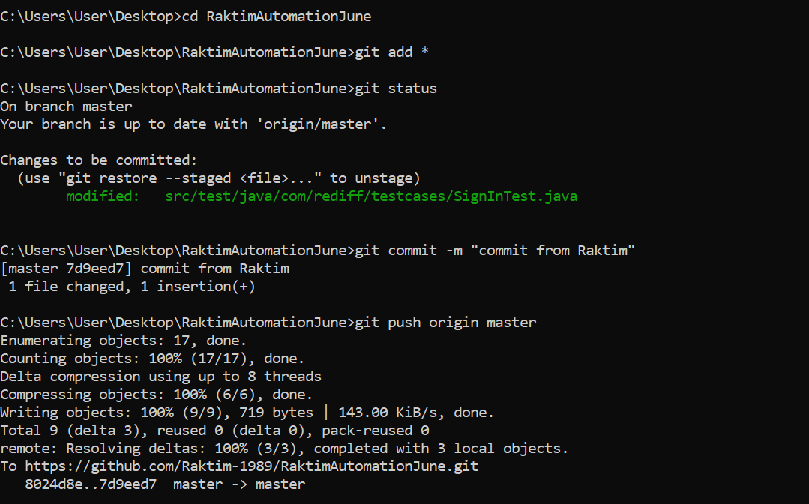

1. **Now again X (working on IST) came and he just needs to see the latest changes. So he will do a ‘pull’ command instead of ‘clone’**

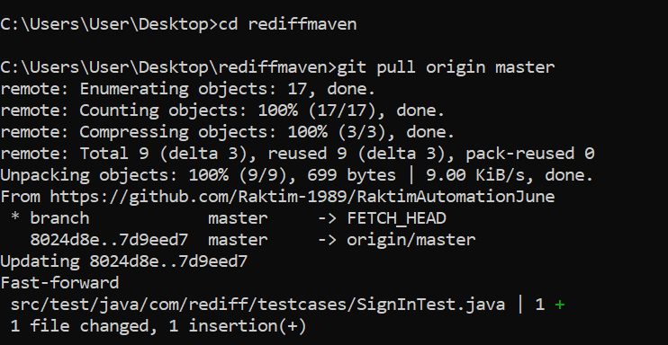

1. **Once X runs this command he will see the change in his eclipse.**

**Flow-> Push (From X) << Clone(From Y) and then Push(from Y) <<Pull(From X)**

The git init command creates a new Git repository. It can be used to convert an existing, unversioned project to a Git repository or initialize a new, empty repository

git init vs. git clone

A quick note: git init and git clone can be easily confused. At a high level, they can both be used to "initialize a new git repository." However, git clone is dependent on git init. git clone is used to create a copy of an existing repository. Internally, git clone first calls git init to create a new repository. It then copies the data from the existing repository, and checks out a new set of working files. Learn more on the [git clone page](https://www.atlassian.com/git/tutorials/setting-up-a-repository/git-clone).

**Tutorial: Branch Concept and merge conflict**

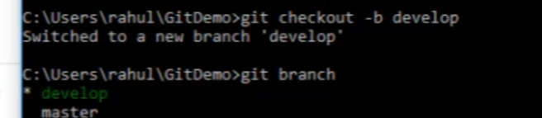

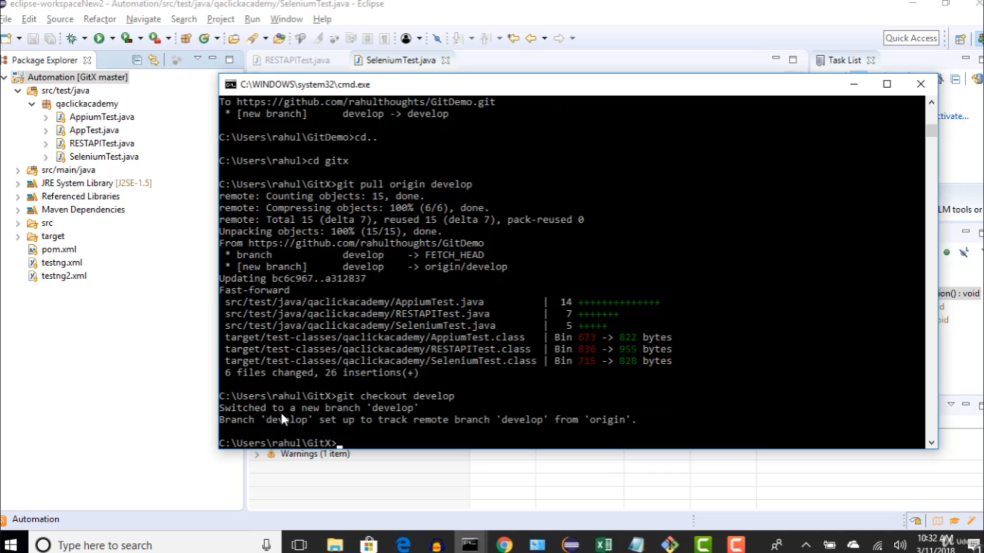

**Branch**

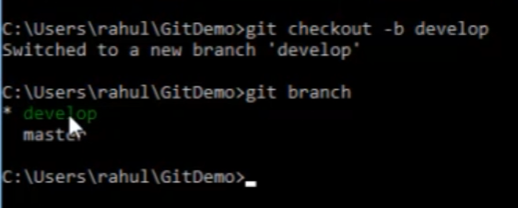

**After switching to develop branch we ae now doing changes in develop branch**

**(testers)**

**(developers) Lastly the developers will switch to master<< then pull from master<< everything will be back into master now**

**The concept is like the following**

**The workaround between two sides**

**Regression testers (tester A & B)**

**Developers (C & D)**

**Developers want to commit their code into their own branch and that’s why they create ‘deveoper’ branch from master and after performing all the task they push the code into the git repo**

**Finally, the regression testers merge the develop branch with their master branch as the following**

**git merge develop**

**after merging they push the code into the git hub (master branch)**

**Lastly the developers switch to master and pull the codes from github (git pull origin master)**